DATE: **12 April 2023**

EVALUATION: **CLOTHING RETAIL - ZALANDO IS MARKET LEADER IN SOME AREAS**

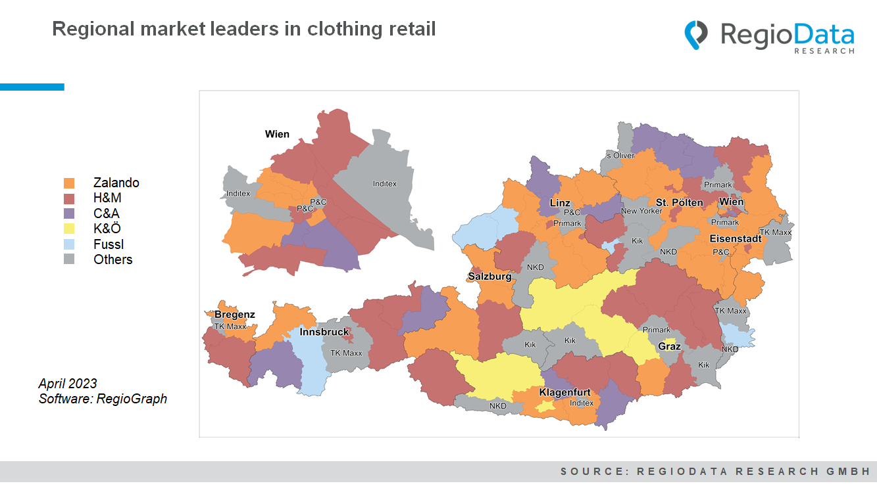

Overall, the clothing retail sector generated approximately €6.3 billion (gross) in turnover in the observation year 2022. Although the total market increased by 21% compared to the previous year, it has not yet reached the pre-crisis level (2019: €6.5 billion).

Among the clothing retailers, H&M is leading the pack, followed closely by Zalando, the online pure player that is steadily gaining market share. Notably, Zalando is able to compete with H&M, especially in rural areas where shopping options are generally limited. When calculating sales per capita and weighting this with the population of the respective districts and online affinity, Zalando is the market leader in 33 districts, on par with H&M.

P&C, C&A, K&Ö, and Fussl rank somewhat below. In line with its family-oriented target group, C&A is the leader in rural parts of the country and in the south of Vienna, thus in districts with lower purchasing power. The situation is similar for Fussl. The fashion house from the Innviertel region of Upper Austria has secured market leadership in its home region, the Tyrolean Oberland, and the tourist region of Güssing in southern Burgenland. K&Ö is a regional player in the south of Austria, with a strong presence around its headquarters in Graz.

In Vienna, H&M is the dominant player, but the weaker retail zones, such as the 8th or 9th district, are supplied by Zalando. The Inditex Group secures the outer districts through its established shopping centers, such as the Donauzentrum or Auhofcenter. In the city center, P&C is currently still the market leader. It remains to be seen how the market dynamics will affect the third-largest clothing chain in Austria by sales following the announcement of P&C's insolvency in Germany.

Discounters such as NKD, Primark, Kik, and TK Maxx are increasingly gaining importance in the clothing retail sector, and have already surpassed the mid-price segment in some rural areas.

*Source:* ***RegioData Research GmbH*** *– Key Industry Figures Clothing*

*Status: 04/2023*