DATE: 19 April 2023

EVALUATION: PET SUPPLIES IN AUSTRIA - SALES NEARLY DOUBLED SINCE 2015

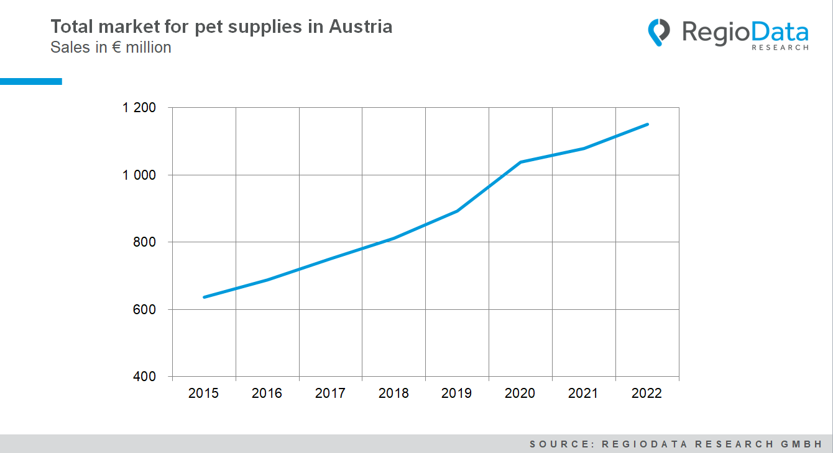

Pets have always been of great importance in Austria, particularly due to its high purchasing power. Around 40% of households in Austria have at least one pet. There are an estimated 1.5 million cats, 800,000 dogs, and 750,000 other pets such as rodents, fish, and reptiles in the country, which is a very high figure by European standards.
The pet industry is therefore a significant economic factor, and the market continues to grow steadily. In recent years, however, the importance of pets has increased significantly, and the industry has almost doubled in size since 2015. In 2015, the pet supplies trade generated around €640 million, whereas, in 2022, it is expected to reach €1.15 billion. The greatest increase in value creation occurred in 2020, with a 16.3% increase in turnover.

During the pandemic, households (particularly young households), especially in urban areas, acquired pets, which fulfilled a certain social function. The market was therefore significantly boosted by the lockdowns. This effect has since diminished somewhat. However, pet food has become much more expensive in recent years. Coupled with the "doing good for animals" mentality, i.e., healthy and high-quality nutrition, as well as medical care, expenses for pet food and veterinary costs have accordingly increased massively.
Per capita spending on pets and pet supplies in Austria is around €130 per year. Pet food accounts for the largest share at 72%, while veterinary care accounts for just under 20%, and the remaining expenses are for the pets themselves and their accessories.
Furthermore, the market is not only large but also highly concentrated, with Fressnapf being the absolute market leader with about 25% of the overall market share. Another quarter of total spending goes through grocery stores, and online pure players such as Amazon or Zooplus account for an additional nearly 20%.

Source: RegioData Research GmbH – Key Industry Figures
Status: 04/2023

