DATE: 23 March 2022

EVALUATION: UNEXPECTED DEVELOPMENT IN THE CLOTHING MARKET: DESPITE CORONA, HARDLY ANY FURTHER LOCATIONS CLOSED

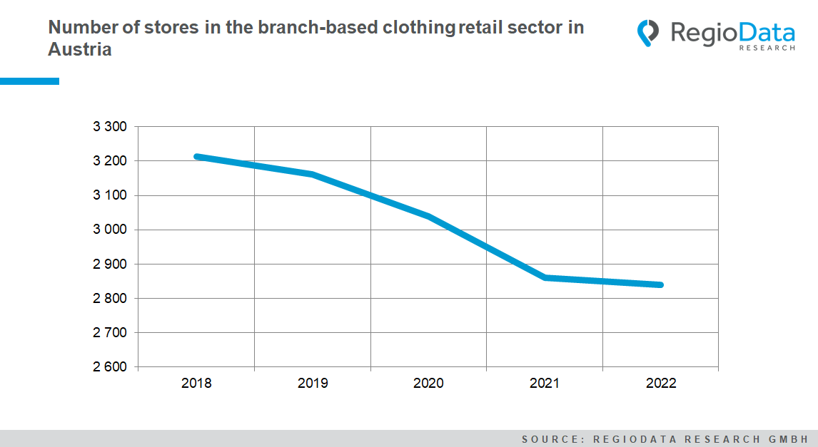

Contrary to expectations, clothing retailers in Austria have recovered to some extent, at least in the recent past, and some market players have even consolidated. With currently about 4,900 clothing locations on the market, there are almost a thousand less than five years ago. However, this downturn does not apply to the entire clothing market: discounters, in particular, have been able to expand massively.
A reduction of around 12% in the number of locations between 2018 and 2022 is observed among the store-based market players, too. Whereas C&A and Palmers have closed minimally, the women's fashion retailers Bonita and Cecil have drastically reduced their locations. With just over 40 Cecil locations in 2018, this year's total counts 8. At Bonita, the reduction amounts to over 55 stores in five years. Due to insolvency, Bonita initially had to reduce the number of locations until the process ended with the decision to maintain and sustain the company last year.

The fact that the women's clothing segment has reduced considerably, is well demonstrated by the former trend retailer Tally Weijl. While 57 Tally Weijl locations were still available in 2018, there are already noticeably fewer, with 28 stores at the current time.
New Yorker, on the other hand, was able to maintain its position well and strengthen it minimally. The situation is similar for Ernsting's family. The German textile retailer expanded its locations in Austria by an additional 16%.
A strong expansion policy is emerging in the non-food discounter market. The NKD Group, in particular, has been able to accentuate its discount supremacy with additional locations. NKD currently has around 300 stores on the Austrian market, making it the market leader. Kik is close behind at a total of 255 stores in Austria. Third-largest textile retailer by locations is Palmers at 173 stores.
In terms of expansion, the European household and clothing chain Pepco is surprising, having entered the market with no less than 29 stores. The discount retailer first gained a foothold in Austria last fall.
Inditex locations with Zara, Bershka, Pull&Bear, and Massimo Dutti remained largely unaffected by Corona. For the sales market leader Hennes & Mauritz, the location status quo has remained unchanged.
All in all, the downward spiral of the mid-priced clothing chain stores has been halted for the time being, while discount stores have further accelerated their expansion plans.

Source: RegioData Research GmbH
Status: 01/2022

