DATE: 24 May 2022

EVALUATION: SHOE RETAIL IN AUSTRIA - SALES AREA SHRINKAGE INTENSIFIES

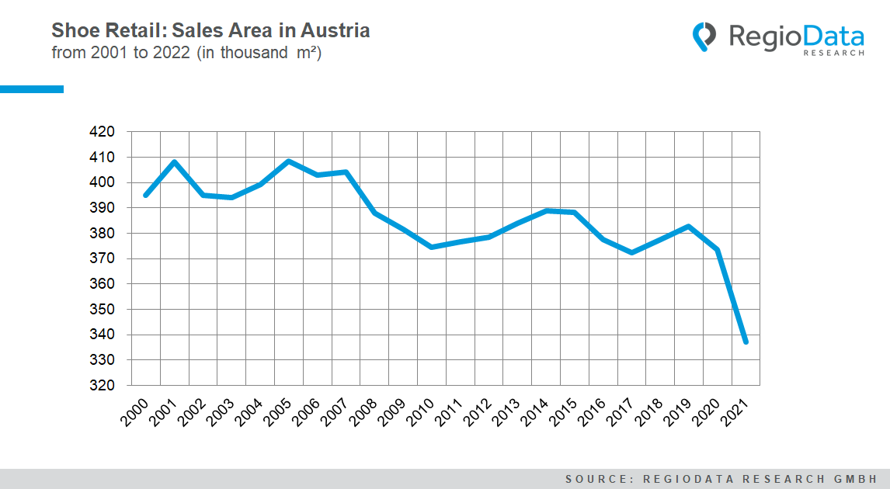
Since the pandemic, sales areas in the Austrian shoe retail sector have been shrinking steadily. To date, the footwear sector has not managed to approach the absolute sales area peak of around 410,000 m² in 2005. However, there have always been ups and downs in between. While more than 380,000 m² of retail space was available in 2019, the current figure of around 330,000 m² is significantly lower.
Accordingly, the total sales area in Austrian shoe retailing will have fallen by 9.5% in 2021, with a simultaneous increase in sales of 5.3%. As a result, the increased productivity per unit area is around 14.7 %. However, this circumstance is due to the withdrawal of CCC. In 2020, the discounter gave up more than 33,300 m² of retail space, which means a decline of about 8% of the total retail space for the shoe trade.
Although the off-price chain store has not disappeared from the market, it has merged into the HalfPrice multi-concept with a new core assortment, namely fashion, shoes, and accessories, hence no longer operating as a pure shoe retailer.
The top 3 shoe retailers with the highest share of sales space remain at the top. First place goes to Deichmann with a current sales area of 80,000 m², closely followed by Leder & Schuh with its Humanic and Shoe4You sales lines along Stiefelkönig with a cumulative sales area of 74,400 m².

Garant claims third place with QuickSchuh and ANWR with around 40,000 m² of sales space. De facto, Garant has reduced its retail space by 15% in the past two years, while most of the big players in shoe retailing stagnated in Corona times.
Online retailing is also making a strong impact here. More than a third of sales in the shoe trade now flow into various online concepts such as virtual marketplaces and multi-channels or are eaten up by pure players.
The Corona pandemic and all its consequences are also an accelerator of the decline in sales space. A direct result of this is the decline in customer frequencies, which is to expect in the future.

Source: RegioData Research GmbH
Status: 01/2022

