DATE: 27 April 2020

EVALUATION: RETAIL RENTS IN AUSTRIA - SIGNIFICANTLY LOWER THAN ASSUMED

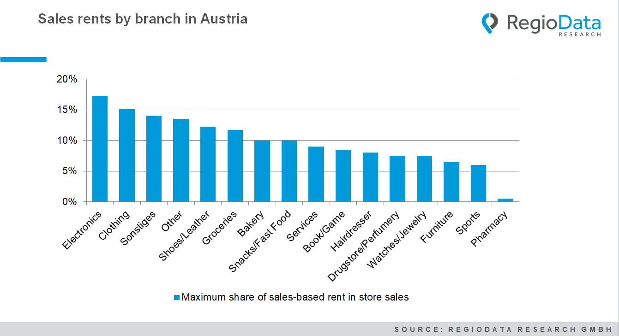
The current study by RegioData Research (survey period: January 2020) analyzes around 1,500 current leases in retail, gastronomy, and retail-related services according to location type, sector, and business size. The results show that the often reported rents in the so-called 1A locations are far from being achieved and that the media often overestimate the rent level.
The highest average rents (minimum rents, cold, net, excluding incidental costs) are achieved in the top locations in Vienna (Mariahilfer Strasse, Goldenes U) in the 300 - 500 m² size class, at € 90/m²/month. In shopping malls with supra-regional importance, the very small stores (10 - 50 m²) are the most expensive at an average of 72 €/m²/month. The highest single values gathered are held by a bakery with approx. 70 m² with 204 €/m² fixed rent at a transport hub in Vienna and a small fast food restaurant with 181 €/m² in a supra-regional shopping mall.Die geringsten durchschnittlichen Mieten von 6 €/m² zahlen Geschäfte mit über 2.000 m² Verkaufsfläche in großen Retailparks, übrigens ist hier die Streuung sehr gering.

It is also noticeable that there are indeed chain stores - even before the Corona crisis - which do not pay rent at individual locations but only cover the operating costs. Primarily affected by this are poorly functioning shopping malls and stores on the high streets of smaller cities.
The share of revenue-based leases is estimated at 20% in the synthetic retail zones, but is largely negligible in the mature retail zones when viewed as a whole. Small electronics retailers and clothing stores pay the highest share of sales here.

Source: RegioData Research GmbH
Status: 01/2020

