DATE: 17 November 2022

EVALUATION: ONLINE AFFINITY IN SPAIN - MAJOR REGIONAL DIFFERENCES

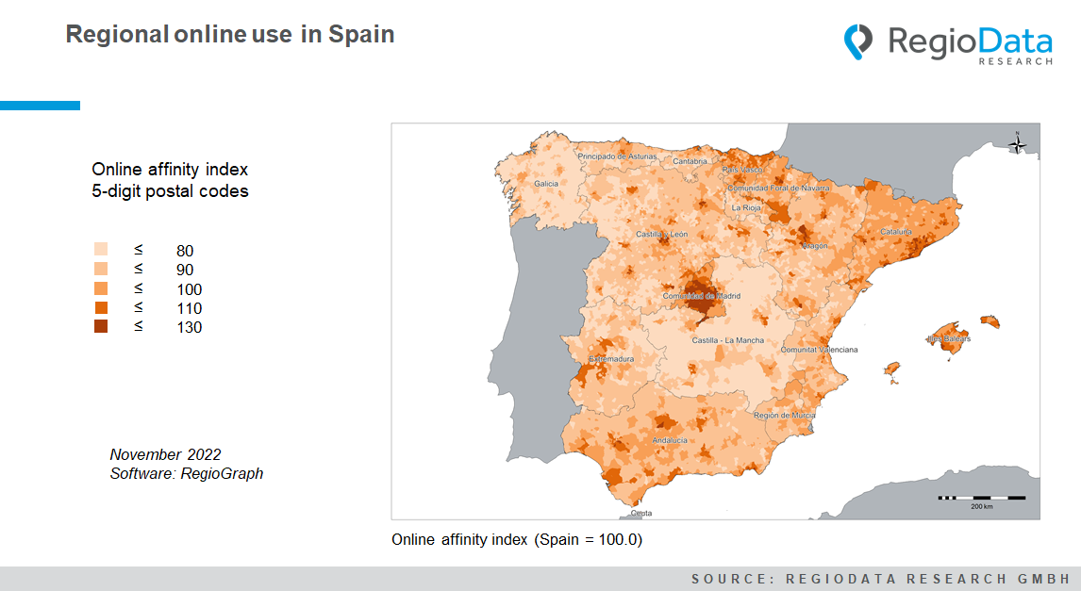

Region-specific differences characterize the actual intensity of Internet use and the willingness to make online purchases. In many countries, urban population groups are significantly more online-savvy - likewise in Spain.
Spanish capitals and major cities, above all Madrid, generate the highest online affinity nationwide. In addition to the increased population density in the Spanish metropolitan areas, tourism also plays a key role. And online services are too widely used in coastal cities. First and foremost, Madrid and the northeast, i.e. Catalonia with the central city of Barcelona, can be classified as having the highest online affinity, although southern areas can also keep up to some extent.
Although southern Andalusia ranks in the middle of the country regarding online affinity, individual parts of the region stand out. The determining factor compared to Galicia, which scores much lower, is Andalusia's large and infrastructurally better developed cities as Malaga, Seville, and Cordoba, which have always been among the most attractive national commercial centers. Accordingly, online affinity is higher.

The most underdeveloped region overall in terms of online technology is the central Spanish autonomous community of Castile-La Mancha. The area lies very close to Madrid and yet has a pretty low level of online affinity. That is not only due to the low population density and high unemployment rate but also to the topographical conditions. The dry region has an agricultural character and is the largest wine-growing area in Spain. These factors, and perhaps the southern lifestyle, massively reduce online affinity.
With an online affinity index of 126 to 128.1, Madrid's districts can claim the top four places among the top 5 most online-fit cities nationwide. Fifth place goes to La Chopera, another Madrid district belonging to the Arganzuela district.
The "last five" are among the regions of Galicia and Castilla-La Mancha. The lowest Internet usage is in the Galician towns of Piquín, Rabal, and Queixa, with an online affinity score of barely 46.4. Sartajada and Montearagón in Castile rank close behind with 46.5.

Source: RegioData Research GmbH – Online affinity Spain
Status: 01/2022

