DATE: 03 March 2022

EVALUATION: MARKET VOLUME OF ONLINE RETAIL IN EUROPE – STATUS QUO

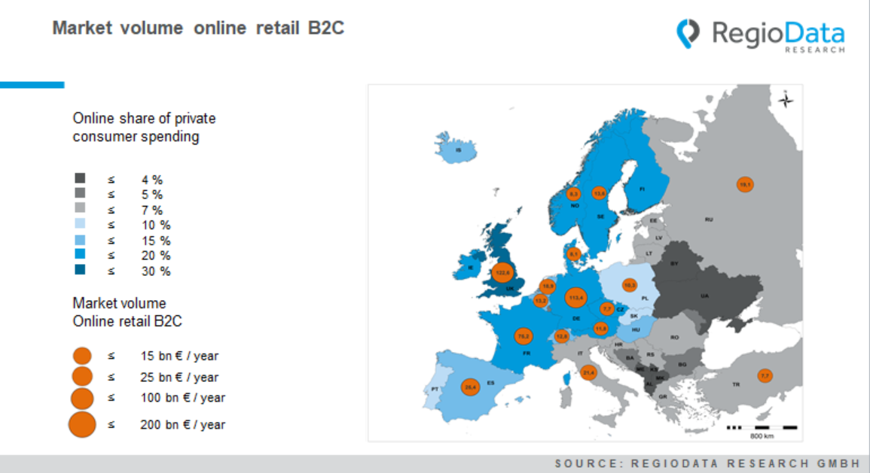

The European market volume in B2C online retail is currently around €530 billion per year. Compared to the previous year, this means an average increase of 4 %, whereby the increases in the western and northern countries are significantly higher. In contrast, in some CEE countries only low growth rates are recorded.
The size of the respective national markets determines by online affinity and population size. Gaps or weaknesses in logistics infrastructure or supply only play a larger role in eastern countries.
In Europe, two large online markets stand out in particular. One is Great Britain which has a traditionally very high online share, especially in the food sector, and the other is Germany with an online spending of more than €100 billion per year. Together, these two countries cover 45% of the entire European market.
The next largest market is France, having an online market volume of "only" €75 billion per year. The remaining large European economies, such as Italy and Spain, are still clearly behind regarding the online consumption.
The rest of Central Europe is in the lower midfield with countries that basically have strong purchasing power, such as Austria, Switzerland and Belgium. In the north, too, the online market volume is still

relatively modest. The result for South-Eastern Europe, specifically in the Balkans, which has a market volume of less than € 1 billion per year, is not very surprising.
In certain parts of the Balkans, as well as in Ukraine and Belarus, private consumer spending goes mainly to stationary trade, which is why this region brings up the rear in Europe regarding online retail.
Europe's front-runner, with a good third of consumer spending going online, is still the UK, closely followed by Northern and Central Europe with around 16 to 20 %. In Russia, Turkey, the Baltic states and in more northern parts of the Balkans, up to 7% of private spending flows into the internet.
To sum up, the market volume of online retailing concentrates in western and central European regions. Nevertheless - with a 40% online share of consumer spending in China, Europe - some countries more than others - still has some catching up to do.

Source: RegioData Research GmbH
Status: 01/2022

