DATE: **16 March 2022**

EVALUATION: **LOCATIONS IN THE FOOD RETAIL SECTOR: YEARS OF EXPANSION HALTED**

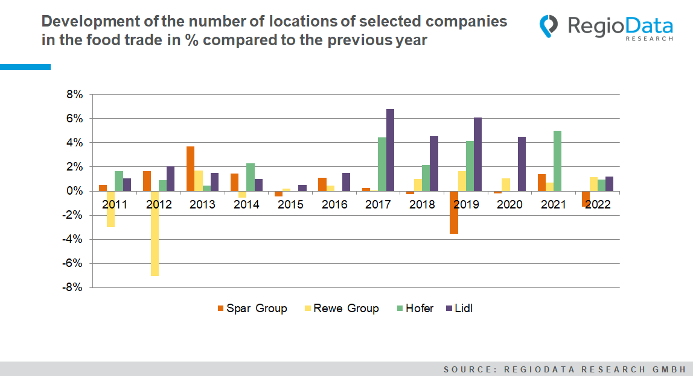

The Austrian grocery trade currently comprises around 5,700 full-range stores, of which the "Big Four" (REWE, Spar, Hofer, Lidl) operate at 3,858. While the number of locations in the grocery trade generally has been declining for many years, the Big Four have, in some cases, expanded rapidly in recent years. But here, too, the ceiling seems to have been reached: the number of locations has remained virtually unchanged compared to 2021.

Location-wise, the title of Austria's top grocery retailer goes to both the Rewe and Spar Group. At the beginning of the previous decade, Rewe prevailed over its main competitor with 1,600 locations to 1,400. Around three years later, this neck-and-neck race took a new turn when Rewe closed 9.7% of its stores from 2010 to 2012, while Spar, along with Euro- and Interspar plus Maxi-markt, expanded its locations in the same period and thus secured the grocery lead until 2018.

Spar ultimately started the new year with over 50 fewer locations, enabling Rewe to climb to the top and hold it to date.

Lidl has also expanded minimally but consistently in recent years. The big leap came from 2017 to 2020 with an extreme expansion policy and annual site growth of around 6%. The situation is similar at Hofer. In the same period and even into 2021, Hofer expanded its locations by a whopping 11%. Nevertheless - regarding the significant lead of the top 2, Spar and Rewe, with well over 1,000 stores more, Hofer and Lidl can hardly top their current position.

Currently, there is almost absolute stagnation on the part of the Big Four. Additionally, Spar has already closed further locations in the new year. Soon, stationary grocery stores could develop in all possible directions with a view to online and hybrid offers such as Billa Click & Collect.

*Source:* ***RegioData Research GmbH***

*Status: 01/2022*