DATE: 03 February 2020

EVALUATION: CONSUMER SPENDING ON DRUGSTORE/PERFUMERY IN EUROPE - SWITZERLAND AND FRANCE TOP THE LIST

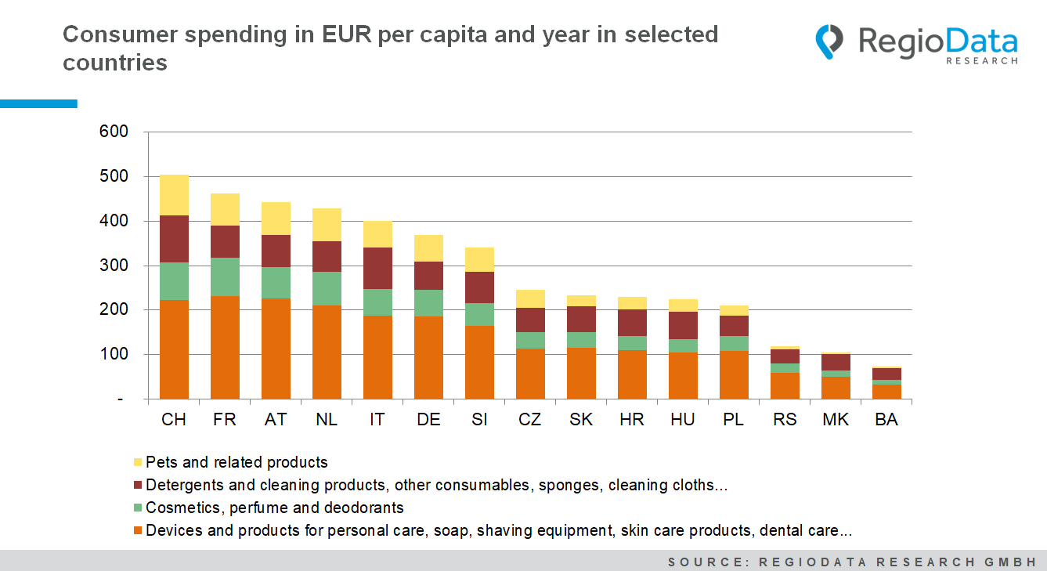

Spending by private households on drugstore and perfumery products has been rising steadily in Europe for more than ten years, albeit at very different levels in the individual countries.
As expected, the highest expenditure - totalling just over €500 per inhabitant per year - is in Switzerland, which has high purchasing power. However, if we look only at the cosmetics and body care subgroups, France is slightly ahead. The lowest spending - probably due to purchasing power - is in Serbia, Bosnia and northern Macedonia, with Bosnia showing the lowest value at just under €75 per inhabitant. The comparatively low spending of just under €370 in Germany is mainly due to the low price level prevailing there, which results from the highly competitive German market environment.
A more detailed look at expenditures in the core product ranges of the drugstore and perfumery trade (body care, cosmetics, household articles/cleaning, pet supplies) reveals that these do not increase evenly in line with higher overall spending: In the high-consumption countries, significantly less money gets spent on "essential" household needs than on the "luxury" products cosmetics and body care. The biggest difference, however, is in spending on pets: at €91, the Swiss spend thirty times more on pets than the northern Macedonians, who only spend around €3.

Source: RegioData Research GmbH – Consumer Spendings
Status: 01/2020

