DATE: 14 November 2022

EVALUATION: WHAT DOES HOUSING COST IN EUROPE? SELECTED COUNTRIES IN COMPARISON.

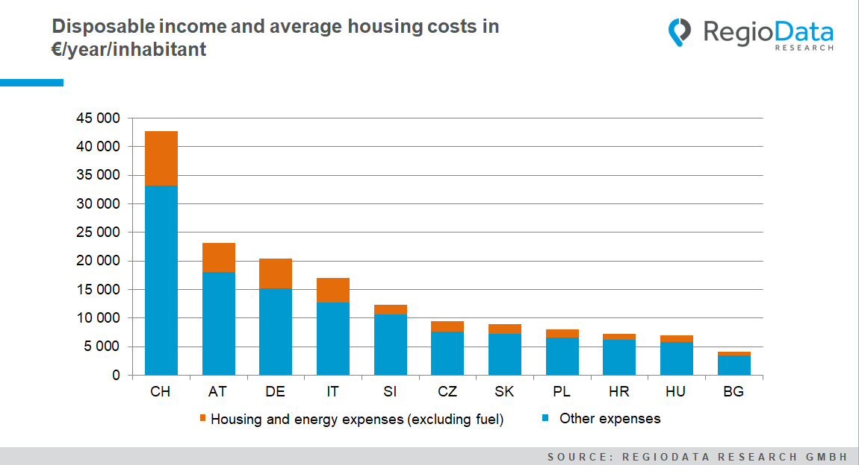

While an average Swiss spends approximately €9,500 per year on housing, including water, electricity, gas, and fuel, and is thus the absolute leader in housing expenditure, Germany comes in second with around €5,200 in housing expenditure. Austrians' housing expenses are only €2 lower, which is why Austria ranks third in Europe in terms of housing costs - but overall has higher purchasing power than Germany, putting it in second place.
Measured by absolute purchasing power per capita, housing costs in Austria and Switzerland account for 22% of the total. At 25%, the share of housing costs in Germany is somewhat higher.
In Italy, maintenance costs are significantly lower at around €4,300 per inhabitant per year, and there is a further leap compared with Slovenia at circa €1,700. The difference in the weighting of the cost breakdown becomes even more apparent: Whereas in Slovenia, only 13% of purchasing power goes to housing costs, in Italy, the slice of the pie is almost twice as high at 25%.

In the other Balkan countries, housing costs as a percentage of total purchasing power are also significantly lower than in the DACH region and most other Western European countries. For example, the average Bulgarian needs only 17% of his income for housing but has only slightly more than 1/3 of Slovenia's purchasing power.
Western and Southern Slavic countries such as Poland, the Czech Republic, Slovakia, and Croatia are close to each other - all of which tend to be at the middle end in terms of both purchasing power and housing expenditure. The average purchasing power here is between €5,800 and €7,600. Bulgaria brings up the rear with a purchasing power of around €4,100. With housing costs of €713 per inhabitant per year, Bulgarians also have the lowest housing costs in Europe.
Hungary's position is interesting as well. With an average annual purchasing power of just under €7,030, which is €140 below the Croatian average, the housing costs of Hungarians are €130 more expensive than those of Croatians.

Source: RegioData Research GmbH – Consumer spending
Status: 01/2022

